REQUIREMENTS ELICITATION

Interviewer**:** Isabella Onneng

Interviewee**:** Kentsenao Baseki

Date: 18/09/25

Based on the elicitation interview the system shall provide the following core functionalities:

Functional requirements:

* The customer is the one who initiates opening the account. A bank teller is to then use the system to register them and create their new account using their personal details.
* Customers should be able to log in to their accounts and the system using credentials provided to them by the bank.
* Once logged in, customers must be able to view their current balance. The system should facilitate customers deposits into any account.
* Customers should be able to easily request closure of any of their active accounts whenever they choose.
* The system should facilitate opening of various accounts for one customer.
* The system should **only** allow deposits into savings accounts and no withdrawals.

Non-Functional Requirements:

* The system should enforce strict data access rules to restrict data access so that customers can only view their own profile and account details.
* The user interface should accommodate **all** users including those with basic computer literacy enabling them to navigate the system with ease.
* Customers should be able to perform core banking operations like viewing accounts and transferring money all the time.
* The system should effectively manage errors to ensure stability and reliability.
* The system should allow multiple users to interact with it simultaneously without degradation of it’s performance.

STRUCTURAL UML MODELLING

1. Use case

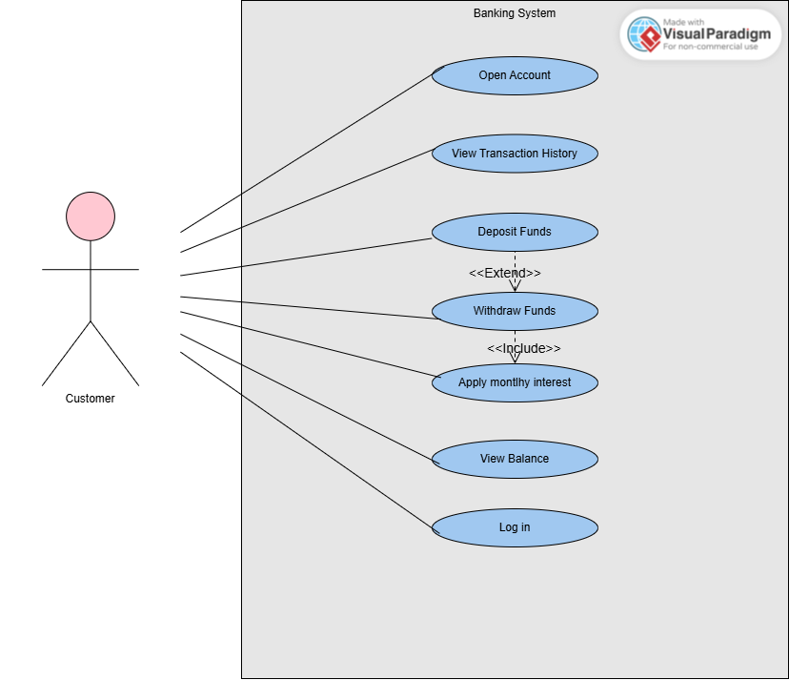

1. Class Diagram

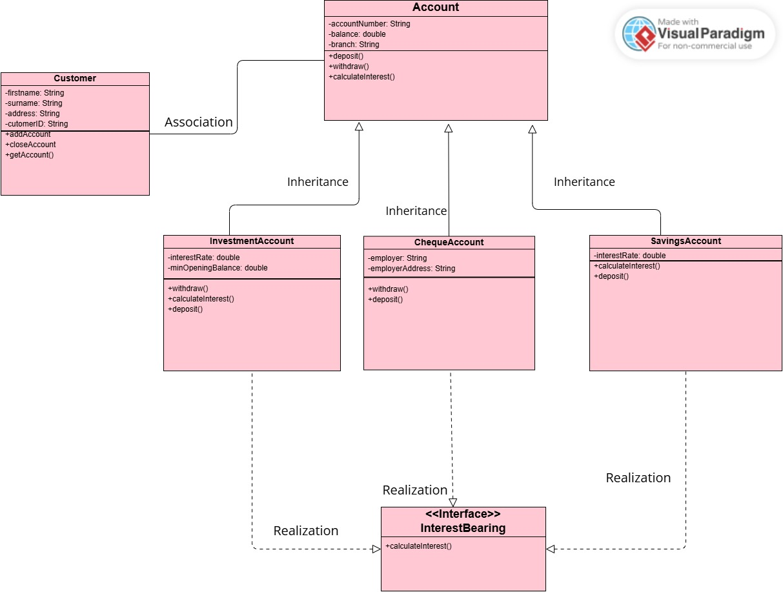

1. Sequence Diagrams
2. 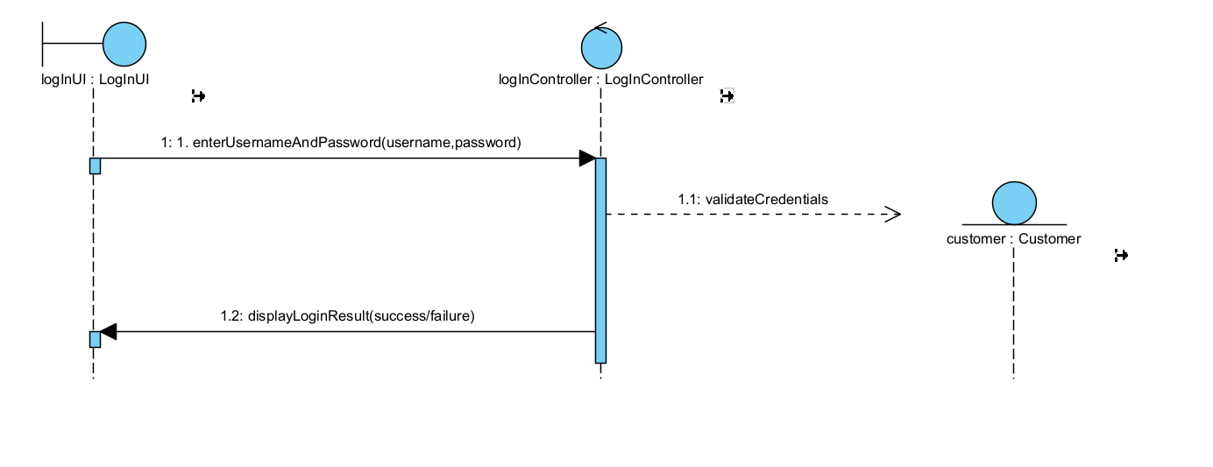
3. 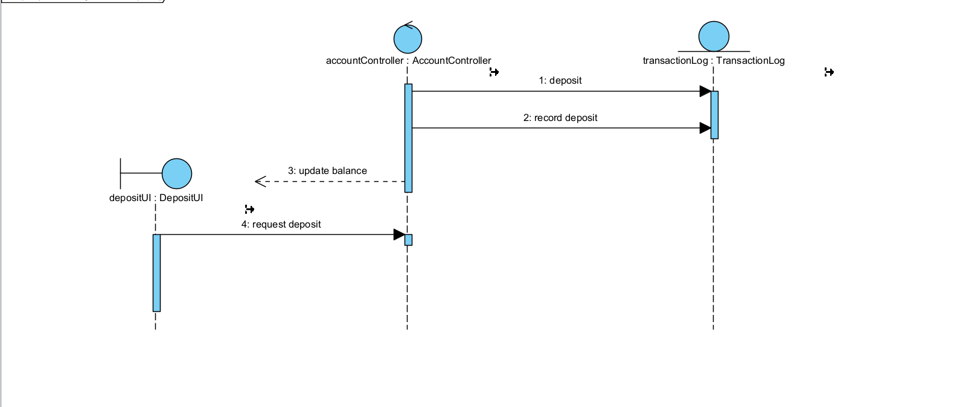
4. A diagram of a state diagram

   AI-generated content may be incorrect.